Lab 5
- Logistic regression binary
# Step 1: Import libraries
import pandas as pd
import matplotlib.pyplot as plt
from sklearn.model_selection import train_test_split
from sklearn.linear_model import LogisticRegression
from sklearn.metrics import accuracy_score

# Step 2: Load dataset
df = pd.read_csv(r"C:\Users\BMSCECSE-SH\Downloads\HR_comma_sep.csv")

print("===== DATASET INFO =====")
print(df.head())

# Step 3: Exploratory Data Analysis (EDA)

# Impact of salary on retention
print("\nSalary vs Retention:")
print(pd.crosstab(df.salary, df.left))

# Impact of department on retention
print("\nDepartment vs Retention:")
print(pd.crosstab(df.Department, df.left))

# Step 4: Plot bar charts

# Salary vs Retention
pd.crosstab(df.salary, df.left).plot(kind='bar')
plt.title("Employee Retention based on Salary")
plt.xlabel("Salary")
plt.ylabel("Number of Employees")
plt.show()

# Department vs Retention
pd.crosstab(df.Department, df.left).plot(kind='bar')
plt.title("Employee Retention based on Department")
plt.xlabel("Department")
plt.ylabel("Number of Employees")
plt.show()

# Step 5: Feature selection (important variables)
# From EDA we select:
# satisfaction_level, average_montly_hours, promotion_last_5years, salary

subdf = df[['satisfaction_level','average_montly_hours','promotion_last_5years','salary']]

# Convert salary to numeric
salary_dummies = pd.get_dummies(subdf.salary, prefix="salary")

df_with_dummies = pd.concat([subdf, salary_dummies], axis='columns')
df_with_dummies.drop('salary', axis='columns', inplace=True)

X = df_with_dummies
y = df.left

# Step 6: Train-test split
X_train, X_test, y_train, y_test = train_test_split(
X, y, test_size=0.2, random_state=42
)

# Step 7: Build Logistic Regression model
model = LogisticRegression(max_iter=5000)
model.fit(X_train, y_train)

# Step 8: Predict
y_pred = model.predict(X_test)

# Step 9: Accuracy
accuracy = accuracy_score(y_test, y_pred)

print("\n===== MODEL RESULT =====")
print("Accuracy of Logistic Regression Model:", accuracy)
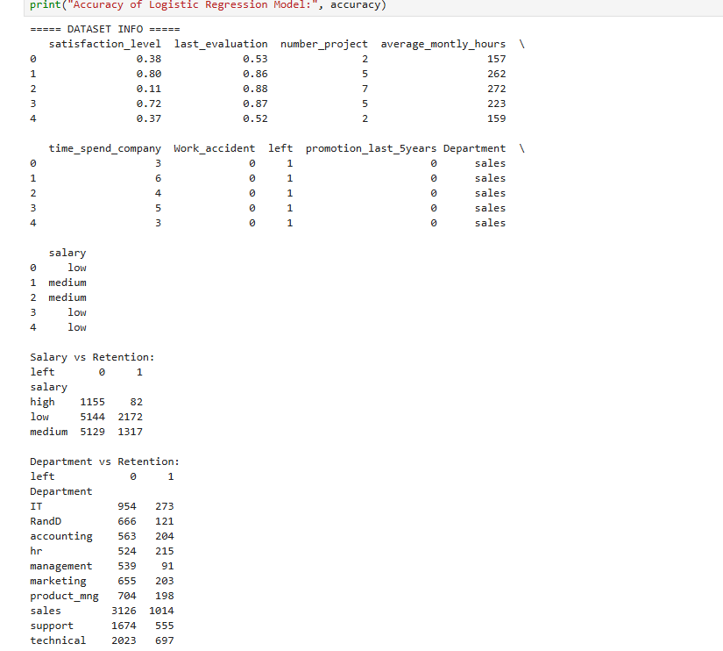

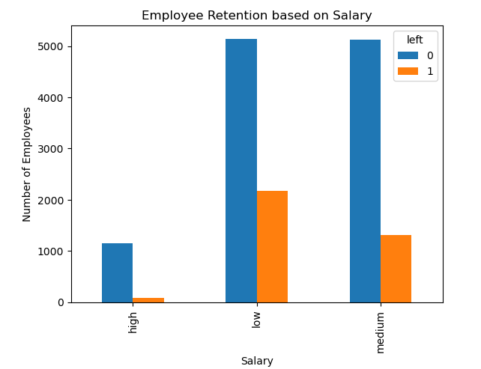
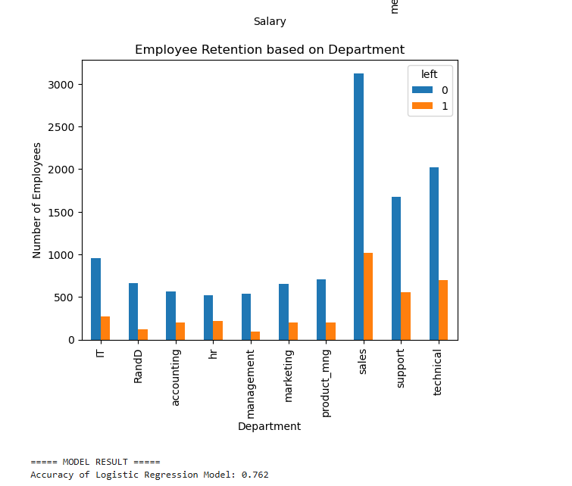
- Multiple classification
# Step 1: Import libraries
import pandas as pd
import matplotlib.pyplot as plt
from sklearn.model_selection import train_test_split
from sklearn.linear_model import LogisticRegression
from sklearn.metrics import accuracy_score, confusion_matrix
from sklearn.preprocessing import LabelEncoder

# Step 2: Load datasets
zoo = pd.read_csv(r"C:\Users\BMSCECSE-SH\Downloads\zoo-data.csv")
class_type = pd.read_csv(r"C:\Users\BMSCECSE-SH\Downloads\zoo-class-type.csv")

print("Dataset Loaded Successfully")

# Step 3: Data Preprocessing

# Drop animal name (not useful for prediction)
zoo.drop('animal_name', axis=1, inplace=True)

# Features and target
X = zoo.drop('class_type', axis=1)
y = zoo['class_type']

# Step 4: Train-test split
X_train, X_test, y_train, y_test = train_test_split(
X, y, test_size=0.2, random_state=42
)

# Step 5: Logistic Regression model
model = LogisticRegression(max_iter=5000)
model.fit(X_train, y_train)

# Step 6: Predictions
y_pred = model.predict(X_test)

# Step 7: Accuracy
accuracy = accuracy_score(y_test, y_pred)

print("\n===== MODEL RESULT =====")
print("Accuracy:", accuracy)

# Step 8: Confusion Matrix
cm = confusion_matrix(y_test, y_pred)
print("\nConfusion Matrix:")
print(cm)

# Step 9: Plot Confusion Matrix
plt.imshow(cm)
plt.title("Confusion Matrix")
plt.xlabel("Predicted")
plt.ylabel("Actual")
plt.colorbar()
plt.show()
